 | BTF  Phone: Fax: |  | 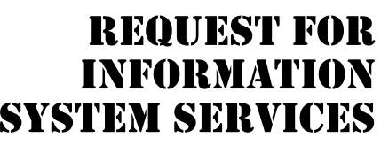
DATE OF REQUEST |  | SERVICE REQUESTED FOR DEPARTMENT(S)
10/13/2022

SUBMITTED BY (key user contact) | EXECUTIVE SPONSOR (funding authority)
Name | Name
Title | Title
Office | Office
Phone | Phone

TYPE OF SERVICE REQUESTED:
Information Strategy Planning Existing Application Enhancement
Business Process Analysis and Redesign Existing Application Maintenance (problem fix)
New Application Development Not Sure
Other (please specify _______________________________________________________________________

BRIEF STATEMENT OF PROBLEM, OPPORTUNITY, OR DIRECTIVE (attach additional documentation as necessary)
Redundant information in the Bahrain Trust Foundation, causing difficulty in processing projects, extreme project delays. To find and contact appropriate donors and volunteers is a lengthy and tedious project that takes a lot of time. Cannot produce effective reports hence no progress to the better in the foundation.

BRIEF STATEMENT OF EXPECTED SOLUTION
New web based solution with a built in DBMS software along with customized dashboard for each user type

ACTION (ISS Office Use Only)
Feasibility assessment approved Assigned to Karak

Feasibility assessment waived Approved Budget __3000BHD___________
Start Date _13/10/2022 _____ Deadline _20/12/2022 ___
Request delayed Backlogged until date: ______________
Request rejected Reason: ________________________________________________
Authorized Signatures:
_____________________________________ _________________________________________________
Project Executive Sponsor

